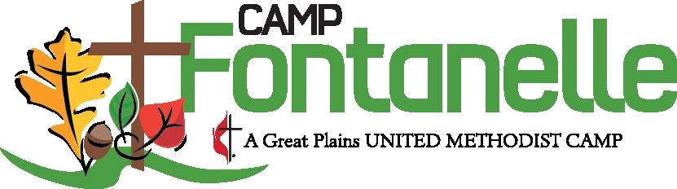

Dear Camper,

We can’t wait for you to come to camp this summer! We have so many exciting things planned for you. There will be lots of fun activities, good food, new friends, time spent in worship and learning about God, opportunities to stretch yourself on new adventures, and much more.

You’ll find your packing list and any special information specific to your program in this packet, so be sure not to lose it. There is also a Camper Questionnaire that you have the option to complete. It gives you a chance to tell your counselors and other staff members about you and the things you enjoy. This will help them make sure you have the best week possible at camp.

This summer we will be learning about how we are all Linked to one another. We will spend the week growing in our connections to one another and learning how to treat each other, even when we disagree. We will do this through fun, interactive, small group lessons each day, as well as all camp worship times where we sing around the campfire, enjoy s’mores, and listen to meaningful and practical messages from deans, counselors, and staff. We hope that what you learn at camp you will take home with you and live out each day.

We pray that you are having a great school year. Be a light to those around you and keep looking to God each day for help and encouragement. Summer will be here before you know it!

Blessings,

Your Camp Fontanelle Staff

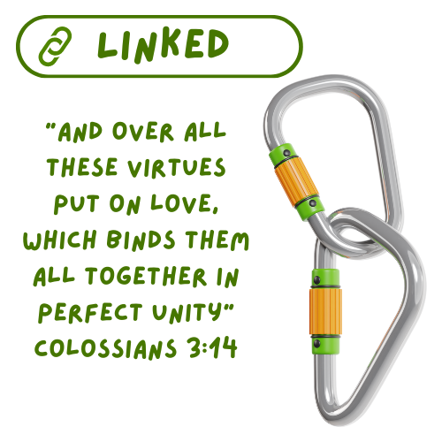

Dear Camper Parent/Guardian,



We are so excited to welcome you to Camp Fontanelle. This packet contains lots of important information about your child’s stay at camp, so please read it carefully, and keep it handy as their time at camp gets closer.

Included are:

* Check-in and check-out times
* Packing list
* Information about this summer’s curriculum
* Camper Mail Options
* Parent/Guardian Get To Know My Camper form

Our primary goal is to provide a safe, fun, Christ-centered experience for all our campers. We are accredited by the American Camping Association which has high standards for camper safety and program experience. Our counselors complete two weeks of training prior to the start of camp each summer. They learn best practices for working with different age groups of children, first aid and CPR, leading Bible studies, and more. We have a health coordinator on staff to handle camper medications and any bumps and scrapes that can sometimes occur while enjoying the great outdoors. Camp Fontanelle is part of the Great Plains United Methodist Conference and all adults working with children are certified through Safe Gatherings and have undergone a background check.   
 If you have not already done so during the registration process, please be sure to have all health forms filled out at least a week before your camper is scheduled to attend. These forms can be completed online through CampBrain or you can visit our website to download and print a hard copy. It is very helpful if you make note of any medications needed, any allergies and/or dietary restrictions, this helps both our health coordinator and our kitchen staff be prepared to help your child have the best week possible. If your child is attending a program that requires an extra release form, please make sure that is also completed when you arrive at camp. Having all of these completed before arrival will help your check-in process go more quickly. Our Get to Know My Camper form is for you to communicate important information about your camper to their counselors and other necessary staff members. This is optional but is extremely helpful for our staff in making each camper feel comfortable during their week at camp.  
 Should you have any questions or concerns prior to your arrival at camp you can contact us via phone at 402-478-4296 or email our camp registrar, Amanda Siver, at asiver@greatplainsumc.org. We look forward to welcoming you to camp this summer!

In Christ,

Your Camp Fontanelle Staff

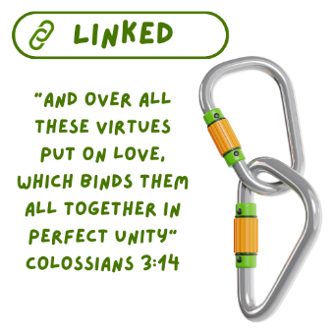**Summer 2024: Linked**

This summer’s curriculum is focused on the ways that we are linked to each other and how we can grow through those connections, despite and often because of our differences. Each day campers will spend time learning about how God has called to live in community with one another; how we treat each other, how we show up for one another in difficult times, how we repair relationships when they are broken, and how we share the love that comes from our community with others. The daily themes will be centered on one aspect of being linked to one another in our daily lives.

We believe strongly that Bible study and learning about God should be interactive, engaging, and fun. Activities are varied in structure, so kids of every learning style have a chance to shine. The categories used in our curriculum are play, pray, create, serve, and learn. Counselors are encouraged to mix up these categories for their daily Bible times throughout the week and to be attuned to what their group of campers respond to the best.

Below is a quick reference of daily themes and scriptures that will be used each week. Programs shorter than the 5-day week will cover just a portion of these based on their program’s length.

|  |  |  |  |  |
| --- | --- | --- | --- | --- |
|  | Scripture | Theme | Story | Camper’s Will |
| Day  1 | Colossians  3:12-14 | Linked in Love |  | * Be invited to think about themselves as beloved * Explore God in the midst of loving relationships * Be encouraged to build deeper connections within the camp community |
| Day  2 | Luke  10:38-42 | Linked through Acceptance | Mary and Martha | * Celebrate that everyone is welcome at camp * Be invited to set aside distractions and be present with each other * Honor the different ways we create and respond to welcome * Imagine the impact of inviting Jesus into their relationships |
| Day  3 | Job  2:11-13 | Linked and Present | Job’s friends | * Acknowledge the power of presence in a friend’s time of need. * Learn that God is with us when we are with each other * Come to know that each person’s emotional needs are unique |
| Day  4 | Luke  15:11-32 | Linked by Grace | The Prodigal Son | * Be assured that God freely offers grace and love to everyone * Learn that owning mistakes is the first step towards reconciliation * Examine how forgiveness in action can be difficult * Explore reconciliation as something to be celebrated |
| Day  5 | 1 John  4:7-9; 19 | Linked to Love |  | * Be reminded that love is from God and that God’s love is an example of how to love others * Be sent to share God’s love in their relationships |